Computer Networks Lab 6

Shagufta Anjum

19XJ1A0568

Steps to set up the network:

1. Create a virtual machine and name it ubuntu. Install Ubuntu OS on it using the iso file downloaded from <https://ubuntu.com/download/desktop>

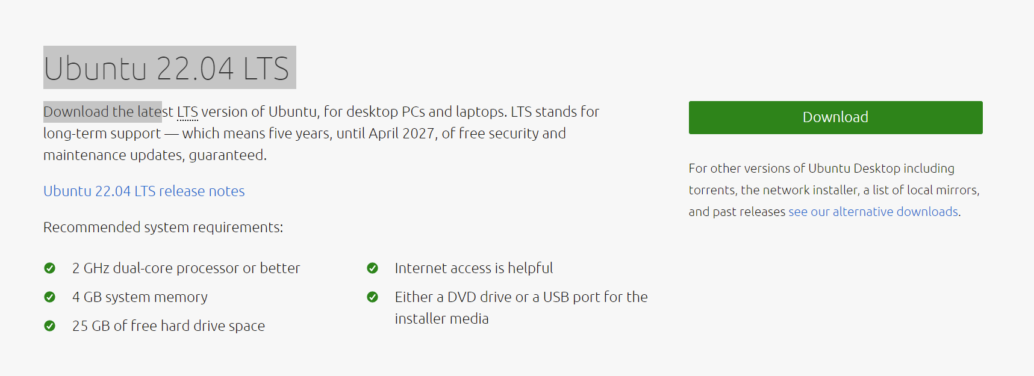

1. Once the VM is set up, run sudo apt update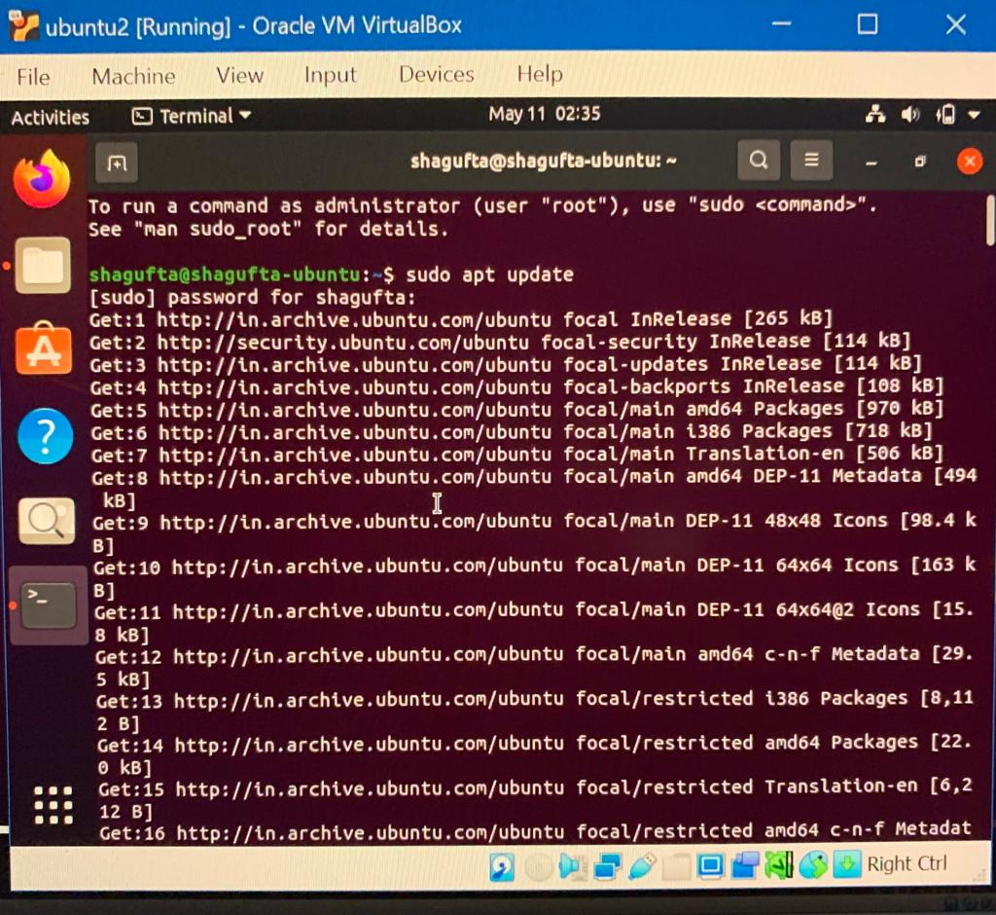
2. Run sudo apt install gcc make perl

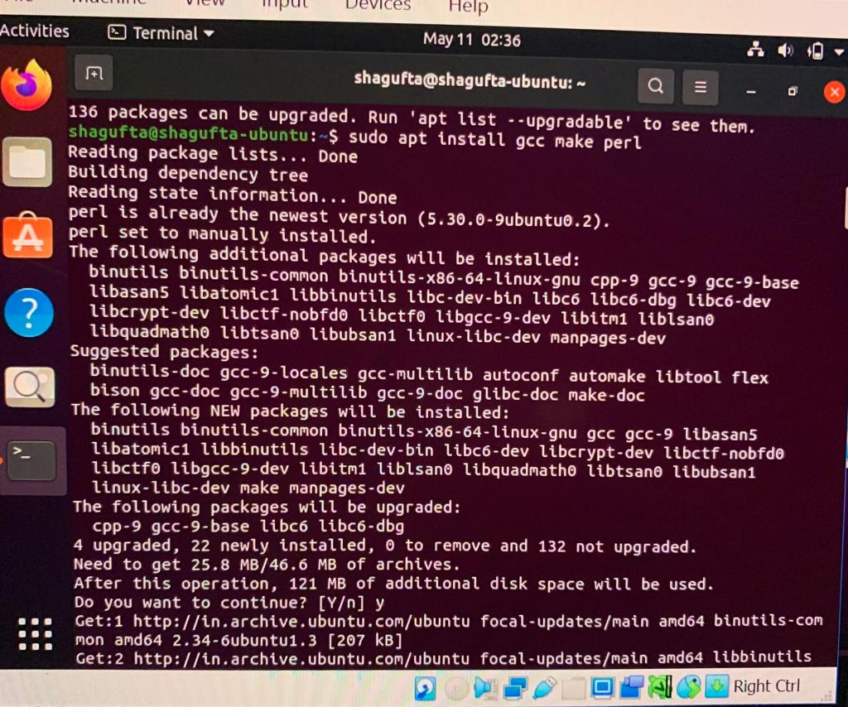

1. Run sudo apt install bridge-utils net-tools iperf3

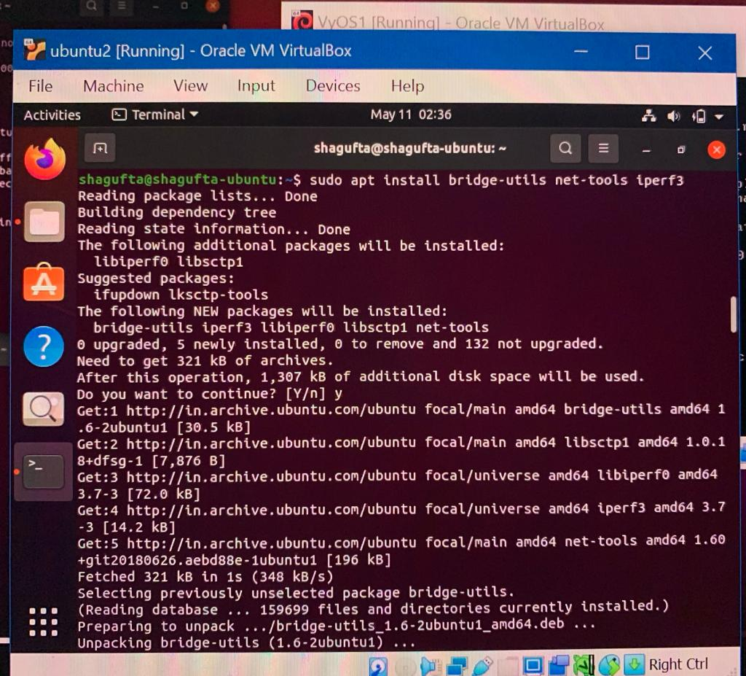

1. Run sudo apt update and sudo apt upgrade and then restart the VM
2. Use ip a to view the list of interfaces
3. Use sudo ip addr add <ip address> dev <interface_name> to add a static IP address to the given interface

Run sudo ip addr add 192.168.101.2/24 dev enp0s3

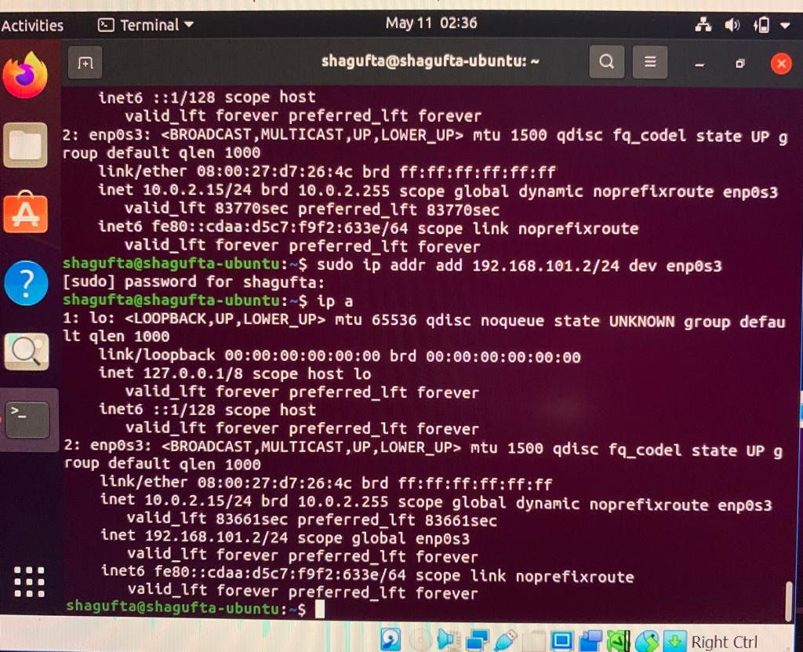

1. Setup a network b1 and add this Ubuntu VM to it.

Go to Settings -> Network -> Attached to -> Internal Network, update name to b1

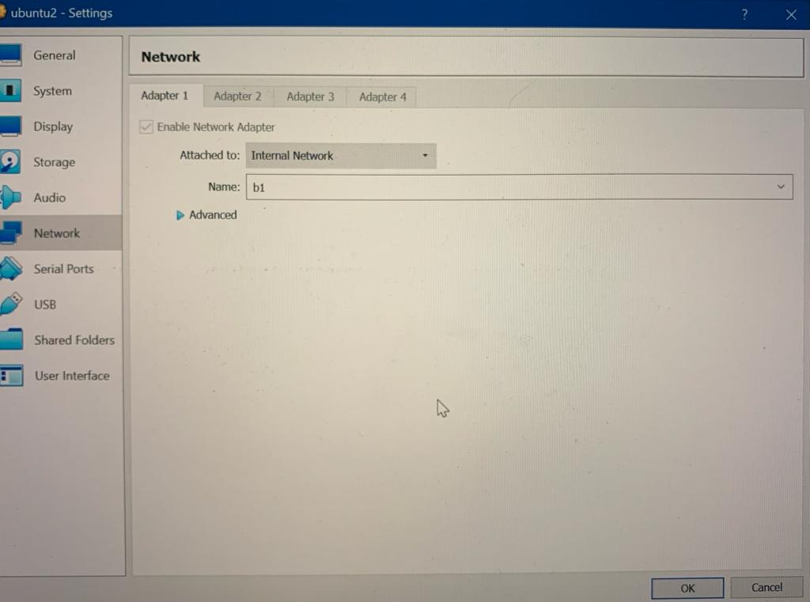

1. Setup a second VM names VyOS1. Install VyOS on it using the iso file from the link <https://vyos.net/get/nightly-builds/>.
2. Add static IP address to interface eth0

Run sudo ip addr add 192.168.101.1/24 dev eth0

Use ip a to view list of interfaces

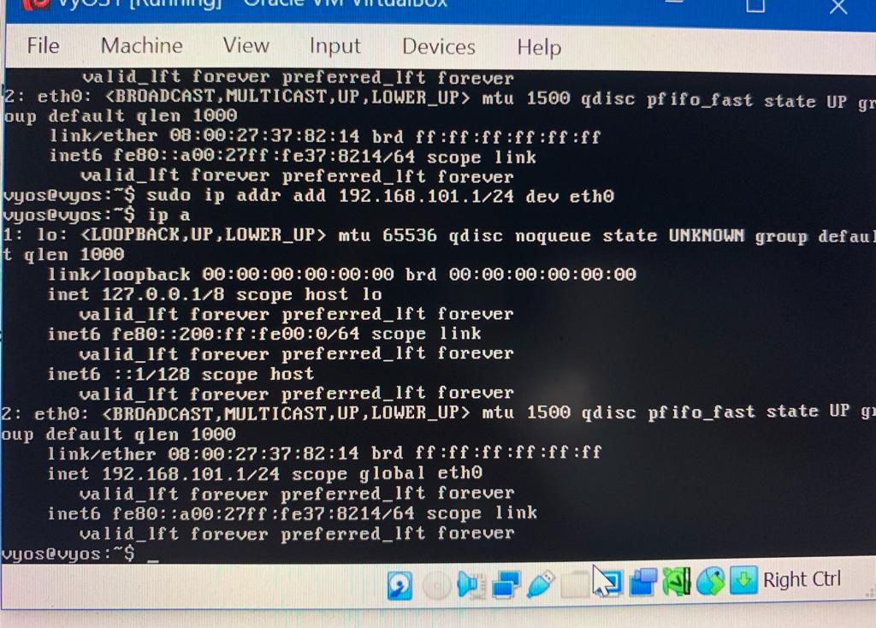

10. Go to Settings -> Network -> Attached to -> Internal Network, update name to b1 for Adapter 1.

Now Ubuntu VM and VyOS VM are on the same network b1.

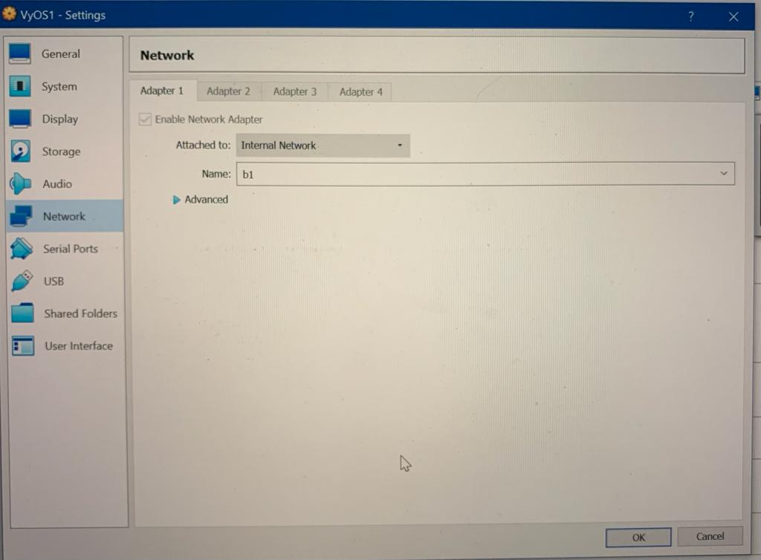

11. Setup a new interface eth1 for VyOS1 VM.

Go to Settings -> Network -> Attached to -> Internal Network, update name to b2 for Adapter 2

Adding this machine to network b2.

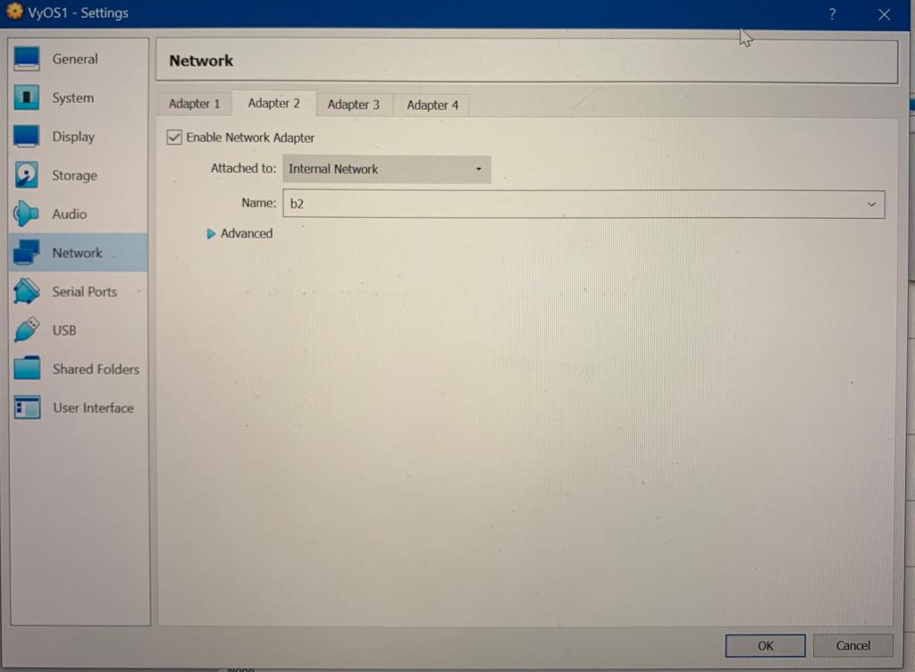

12. Add IP address to this new interface on network b2

sudo ip addr add 192.168.100.1/24 dev eth1

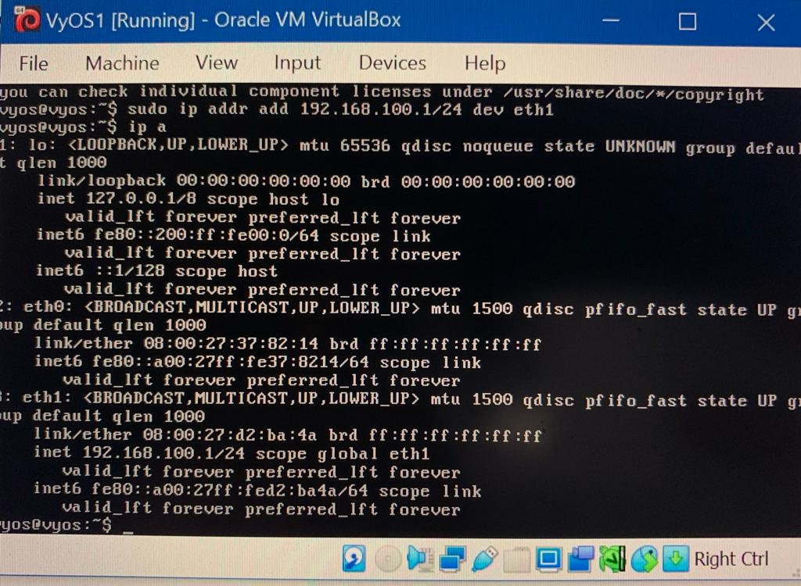

13. Setup a third VM named VyOS2. Install VyOS on it using the iso file from the link <https://vyos.net/get/nightly-builds/>.

14. Run sudo ip addr add 192.168.100.2/24 dev eth0 to add a static IP address to interface eth0

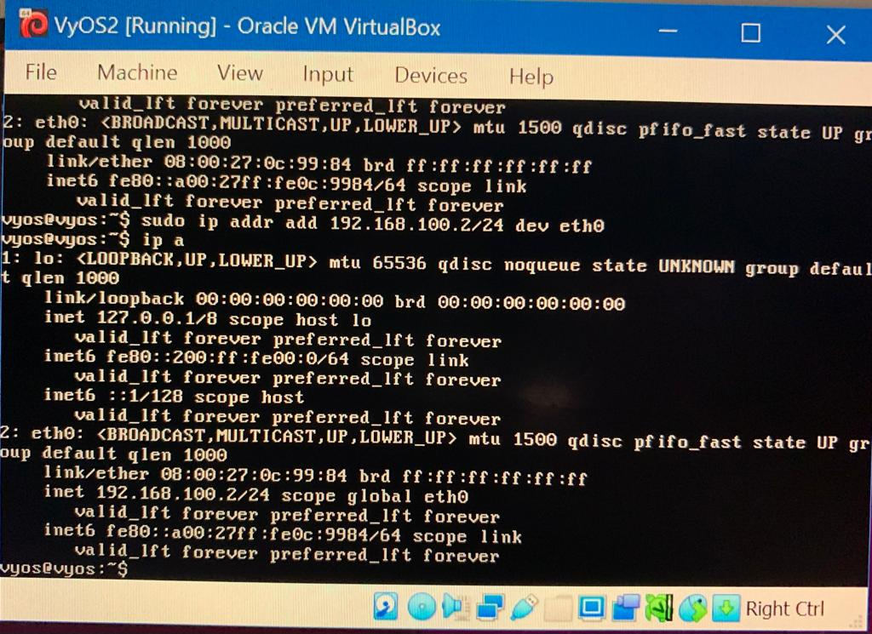

15. To setup routing from VyOS2 to Ubuntu, run sudo ip route add 192.168.101.0/24 via 192.168.100.1

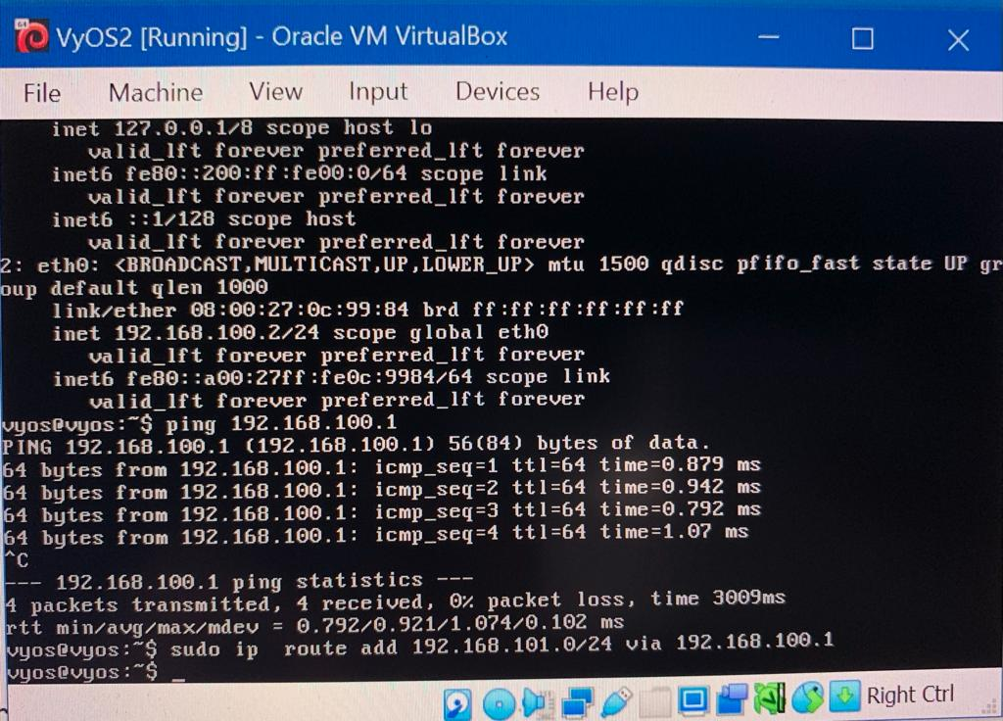

16. To setup route from Ubuntu to VyOS2, Run sudo ip route add 192.168.100.0/24 via 192.168.101.1

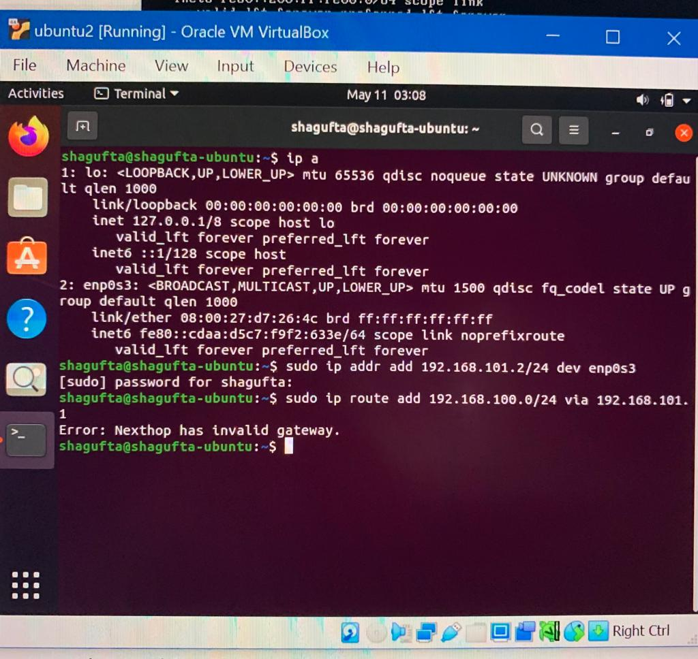

17. Ping to check if routes work

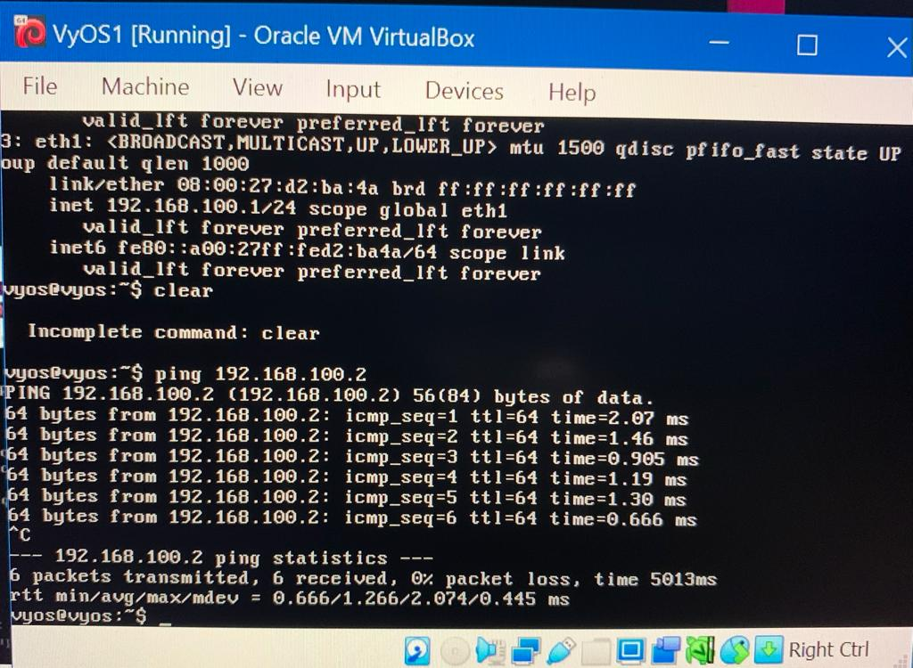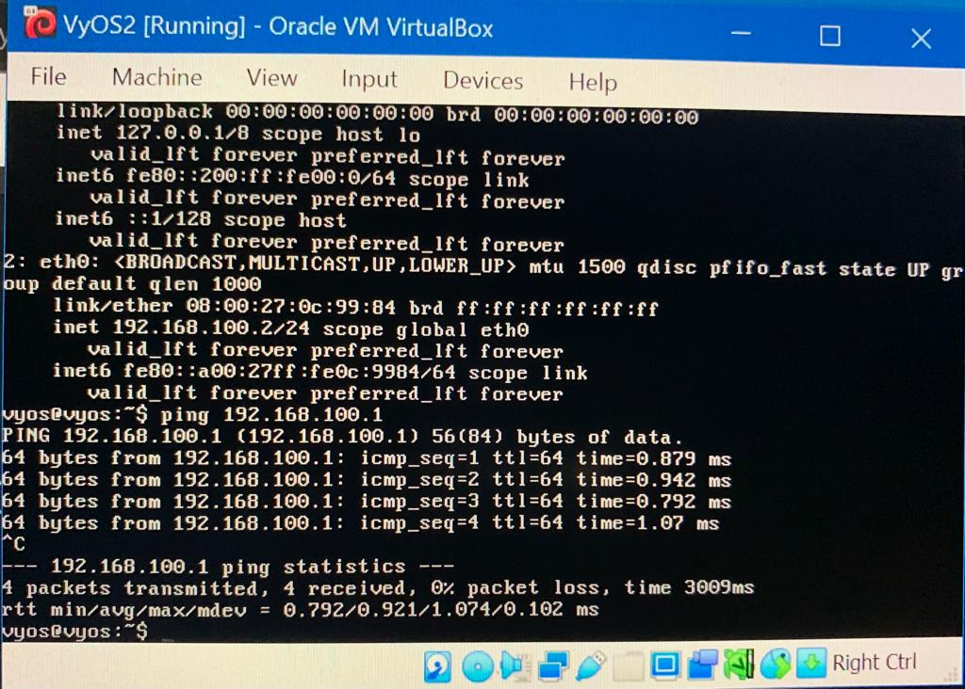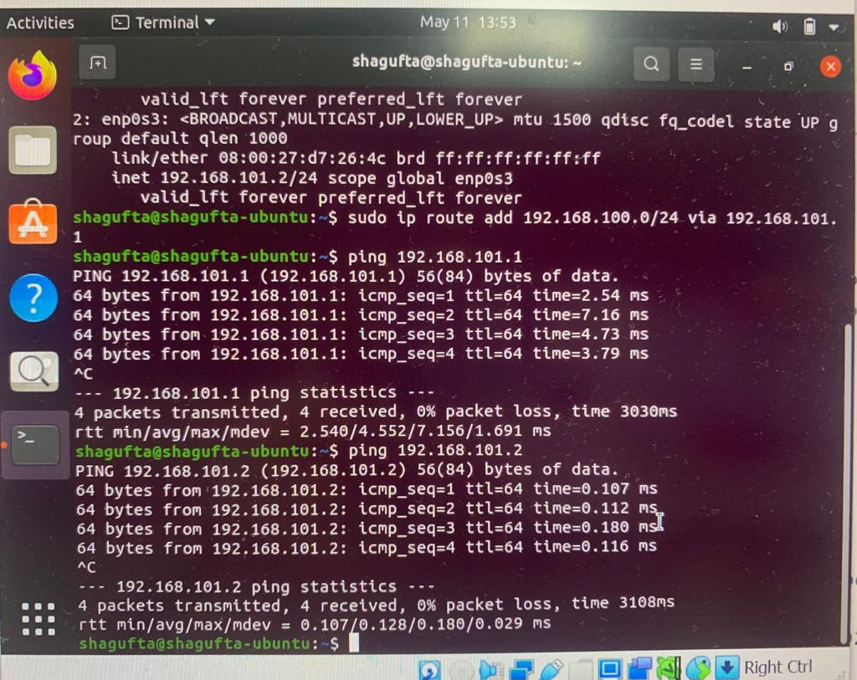

Ping works successfully!